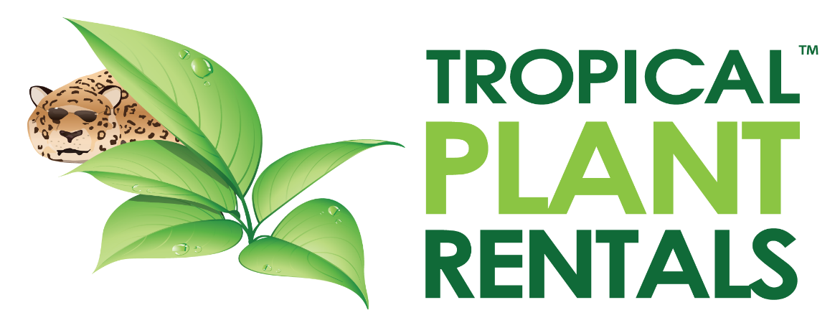

Indoor Plant Technician

We provide office plant hire & maintenance to offices throughout Sydney, CBD & Sydney metropolitan areas to our corporate clients. We are currently looking to add to our team an enthusiastic and well-presented Indoor Plant Technician to assist with plant servicing.
Currently offering full time & part time roles for plant technicians, working predominantly in Sydney CBD. Frequent visits to our HQ & nursery located in Annangrove are a requirement. Good hourly wage + bonuses
Daily duties include-
Plant Watering, trimming, removal of spent foliage.
Application of disease & pest preventative.
Installation of new plants to client’s premises, Plant removals and changes.

Candidates must be-
Reliable and punctual
Well presented
A good communicator
Enthusiastic and have a great work ethic

Full training will be provided however previous industry experience or Horticulture Certificate will be highly regarded.
Uniforms, required tools and a fully maintained company vehicle will also be provided.
Email us your resume to
jenna@tpr.com.au

